Storage Types
There are two main types of storage that we can use to store the data, block and object.
Example: I have a 1-gigabyte file with text,
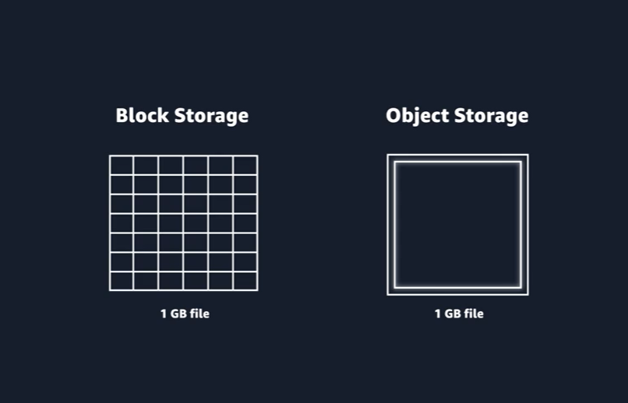
In block storage, file is split into fixed size chunks of data and then stored. Object storage treats each file like a single unit of data.
Storage services are grouped into three categories:
- File storage- Data is stored as files in a hierarchy
- Block storage- data is stored in fixed-size blocks
- Object storage- data is stored as objects in buckets
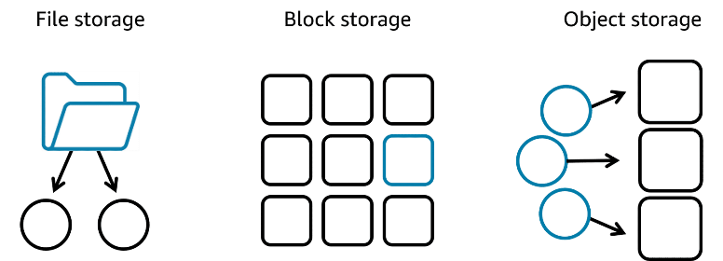
FILE STORAGE
- Familiarity: File storage is similar to systems like Windows File Explorer or macOS Finder.
- Organization: Files are arranged in a tree-like hierarchy of folders and sub-folders.
- Example: To organize cat photos, you might create a Cat photos folder and place it inside Application files for application use.
- Metadata: Each file has attributes such as file name, file size, and creation date.
- File Path: Files have paths (e.g., computer/Application_files/Cat_photos/cats-03.png) used to locate them.
- Centralized Access: File storage allows multiple hosts to share and manage files efficiently.
- Technical Requirements: It typically requires mounting on multiple hosts, file locking, and integration with file system protocols.
Use cases for file storage
- Web serving
- Analytic s
- Media and entertainment
- Home directories
BLOCK STORAGE
- Unit of Storage: File storage treats a file as a single unit, whereas block storage splits a file into fixed-size chunks called blocks.
- Addressable Blocks: Each block has its own address, allowing efficient retrieval.
- Data Assembly: When data is requested, blocks are organized using their addresses to reconstruct the complete file.
- Minimal Metadata: Blocks only have addresses; no additional metadata is stored with each block.
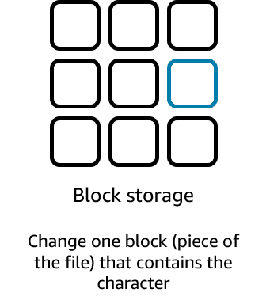
Use cases for block storage
- Transational workloads
- Containers
- Virtual machines

OBJECT STRAGE:
- Unit of Storage: Object storage stores files as objects, each treated as a single, distinct unit of data.
- Storage Structure: Objects are stored in a flat structure called a bucket, without folders or hierarchical directories.
- Unique Identifier: Each object has a unique identifier.
- Metadata: Objects store their data along with metadata and the identifier together.
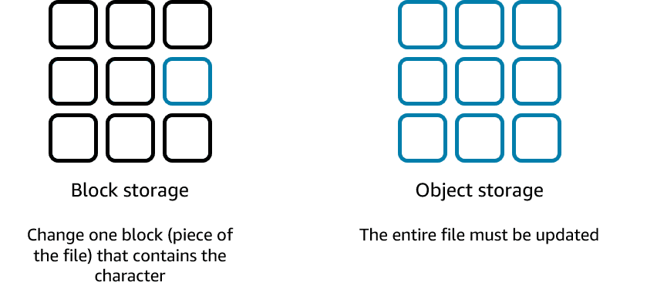
Use cases for object storage
- Data archiving
- Backup and recovery
- Rich media

Block storage in the cloud is analogous to direct-attached storage (DAS) or a storage area network (SAN).
File storage systems are often supported with a network-attached storage (NAS) server.
Resources
(opens in a new tab)For more information, see the following resource:
AWS website: Cloud Computing Concepts Hub

